Pole docking equations.

Two distinct situations:

Right and left climb.

# Right climb:

## Report geometry

The report geometry is:

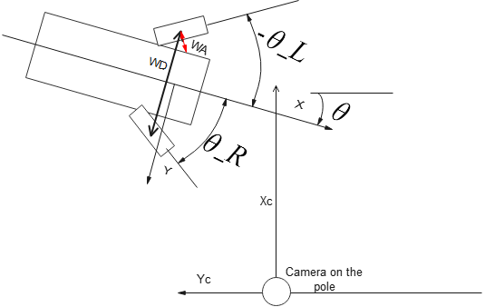

Assumptions:

For the entire pole docking process, the steering angles are exactly opposing,

$θ_{R}=-θ_{L},θ_{R}≥0$. This assumption implies that the wheel touch line remains always parallel to the robot local Y.

The following distance are defined:

|  |  |
| --- | --- |
| WA | Length of wheel connection arm (about 6cm) |
| SD | Distance between robot steering joints |
| WD | Distance between wheel touch points $WD=SD+2WAcos\left(θ_{R}\right)$ |
| $$θ$$ | Robot yaw, w.r.t. shelf line |
| $$θ_{s}$$ | Steering angle. $θ_{S}=θ_{R}=-θ_{L}$ |

The target is expressed in robot body coordinates as

$${-x}_{t}=y_{c}cos\left(θ\right)+x_{c}sin\left(θ\right)$$

$${-y}_{t}={+x}_{c}cos\left(θ\right)-y_{c}sin\left(θ\right)$$

## Steering to the target

The robot targets towards $x=x_{t},θ=0$

When the wheels are straight, this is very simple:

Right distance = $x_{t}-θ⋅K_{θ}$

Left distance = $x_{t}+θ⋅K_{θ}$

$$K_{θ}=\left\{\begin{matrix}\frac{WD}{2cos\left(θ_{s}\right)} & : & cos\left(θ_{s}\right)>0.7 \\ \frac{WD}{2cos\left(θ_{s}\right)}⋅max\left(\frac{cos\left(θ_{s}\right)-0.5}{0.2},0\right) & : & Otherwise\end{matrix}\right.$$

Comments:

* The expressions above neglect that distance the wheel travels about WA. As this distance is automatically compensated by the wheel speed driver
* We have $cos\left(θ_{s}\right)$ at the denominator. For small values of $cos\left(θ_{s}\right)$, there will be also a lot of skidding. Therefore, the voiding of $K_{θ}$ for large steering angles

## Left climb.

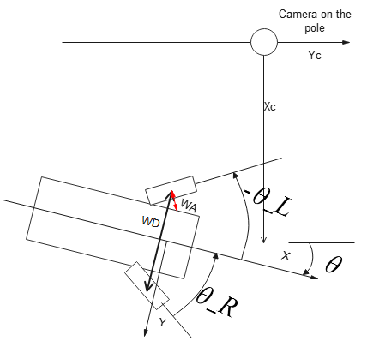

We have here (simply both the Xc and the Yc axes are negated)

$${-x}_{t}={-y}_{c}cos\left(θ\right)-x_{c}sin\left(θ\right)$$

$${-y}_{t}={-x}_{c}cos\left(θ\right)+y_{c}sin\left(θ\right)$$

# The final approach

The robot approaches the pole start run line.

It has no more maneuvering options, so it just checks precision.

If precise enough, go on climb; otherwise straighten wheels and restart maneuver

## Right travel error calc

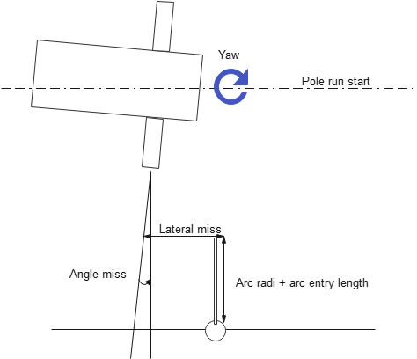

The angle miss is the robot’s relative yaw.

We have (assuming that the angle miss is small, otherwise the calculation is anyway irrelevant)

$$ϵ=x_{t}+θ_{t}⋅{(y}_{t}-Arc radi-arc length entry)$$

## Left travel error calc

We have (assuming that the angle miss is small, otherwise the calculation is anyway irrelevant)